Assingment 2

1.What are the two values of the Boolean data type? How do you write them?

Ans. The 2 values of boolean are True and False. both of them are case sensitive and with the same spelling.

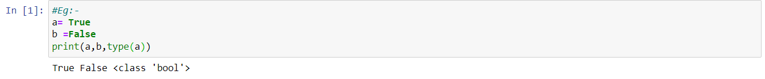

2. What are the three different types of Boolean operators?

Ans. The 3 different type of Boolean operators are and, or & not. The Boolean operators are used to compute boolean values.

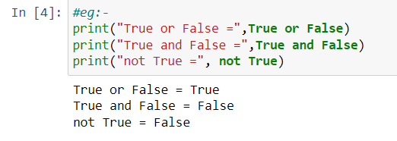

3. Make a list of each Boolean operator's truth tables (i.e. every possible combination of Boolean values for the operator and what it evaluate ).

Ans. And Table

|  |  |  |
| --- | --- | --- |
| True | True | True |
| True | False | False |
| False | True | False |
| False | False | False |

Or Table

|  |  |  |
| --- | --- | --- |
| True | True | True |
| True | False | True |
| False | True | True |
| False | False | False |

Not Table

|  |  |
| --- | --- |
| True | False |
| False | True |

4. What are the values of the following expressions?

(5>4) and (3 == 5)

not (5 > 4)

(5 > 4) or (3 == 5)

not ((5 > 4) or (3 == 5))

(True and True) and (True == False)

(not False) or (not True)

Ans- (5>4) and (3 == 5) => False

not (5 > 4) => False

(5 > 4) or (3 == 5) => True

not ((5 > 4) or (3 == 5)) => False

(True and True) and (True == False) =>False

(not False) or (not True) =>True

5. What are the six comparison operators?

The six comparison operators are ==,<,>,<=,>=,!=.

6. How do you tell the difference between the equal to and assignment operators? Describe a condition and when you would use one.

Ans. The equal to operator are used to compare between 2 values while assignment operator is used to store value in a variable

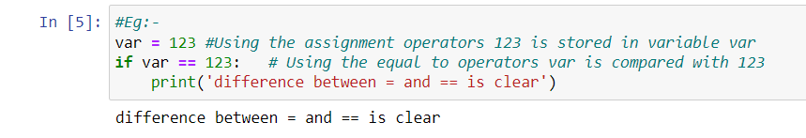

7. Identify the three blocks in this code:

spam = 0

if spam == 10:

print(‘eggs’)

if spam > 5:

print(‘bacon’)

else:

print(‘ham’)

print(‘spam’)

print(‘spam’)

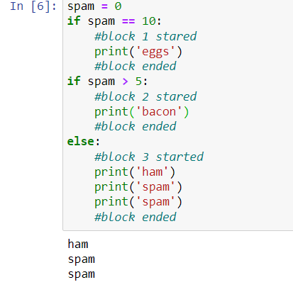

8. Write code that prints Hello if 1 is stored in spam, prints Howdy if 2 is stored in spam, and prints Greetings! if anything else is stored in spam.

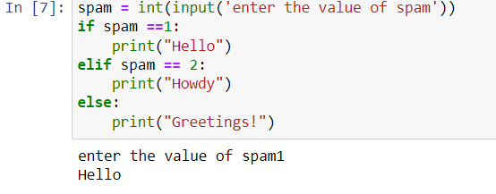

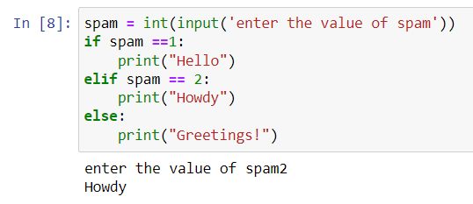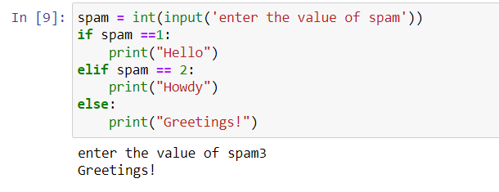

9.If your programme is stuck in an endless loop, what keys you’ll press?

Ans. ctrl+c

10. How can you tell the difference between break and continue?

Ans. break statement is used to terminate the loop while continue statement skip the current execution.

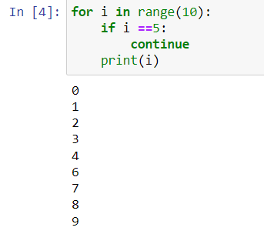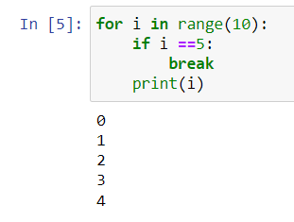

11. In a for loop, what is the difference between range(10), range(0, 10), and range(0, 10,1)?

Ans there is no difference in the execution. In range(10) we only have given the ending point. In range(0,10) the starting and ending point are given. In range(0,10,1) the starting point the ending point and the steps are given.

12. Write a short program that prints the numbers 1 to 10 using a for loop. Then write an equivalent program that prints the numbers 1 to 10 using a while loop.

Ans.

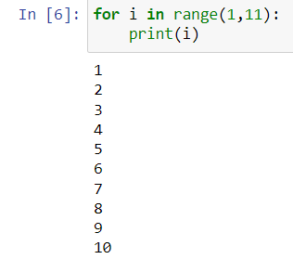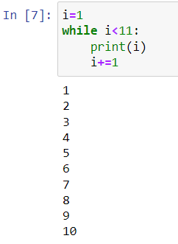

13. If you had a function named bacon() inside a module named spam, how would you call it after importing spam?

Ans. spam.bacon()